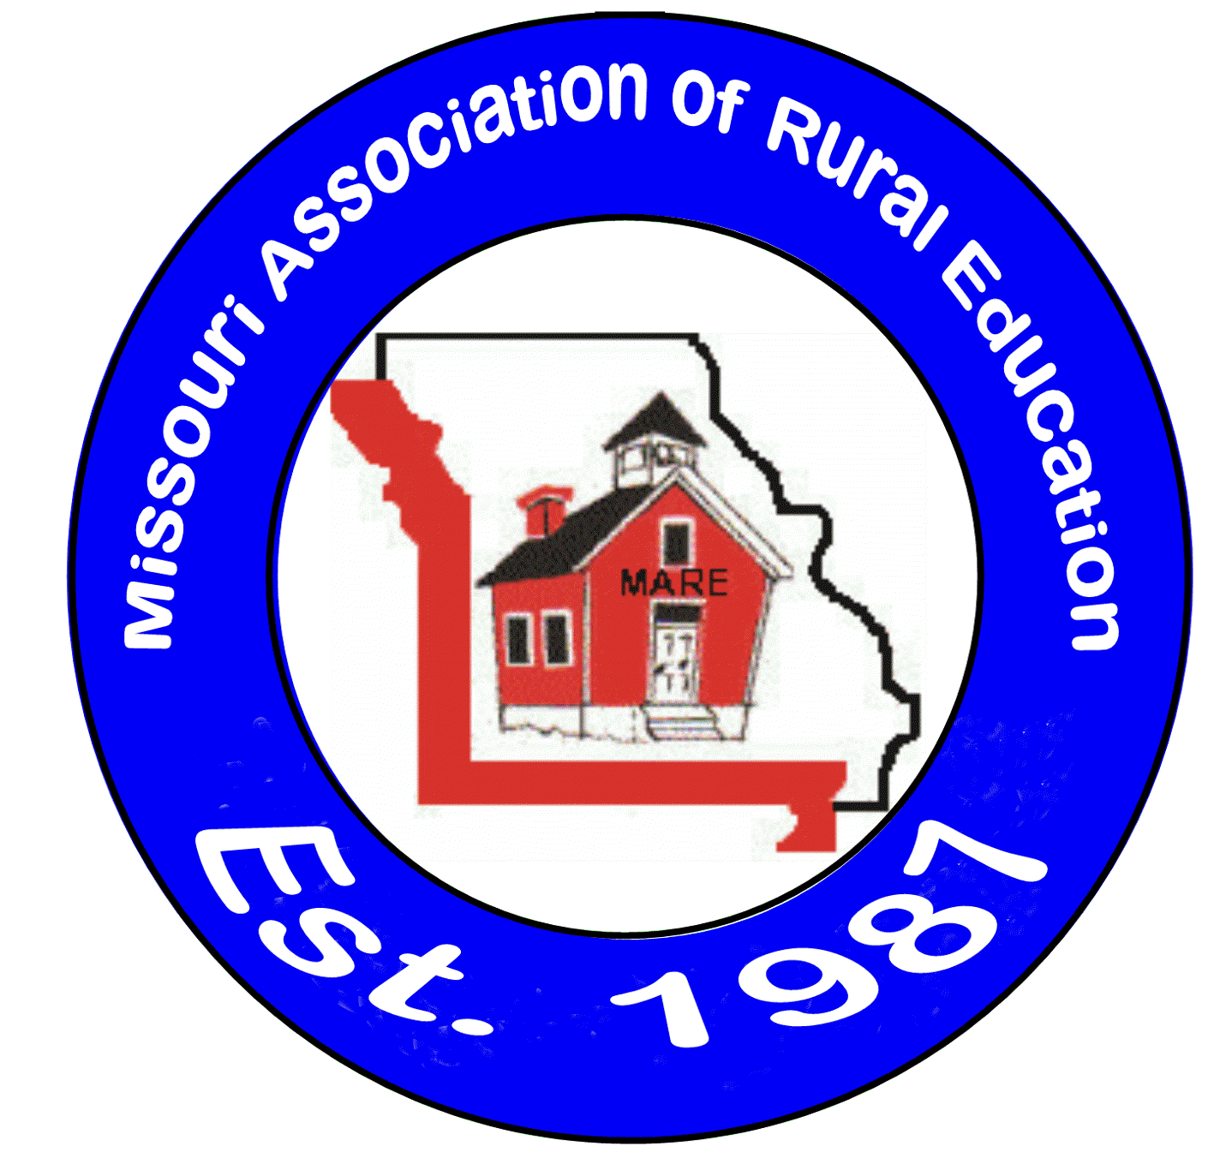14th Annual MARE
Scholarship Golf Tournament
Corporate Sponsorship Information

Osage National Golf Course – Lake Ozark, Missouri
Monday, July 15th, 2024
Registration from 9:30-11:45 a.m.
Lunch Served from 10:45-11:45 a.m.
12:00 Noon Shotgun Start - Four Person Scramble

Founding Collaborator Flight: $5,000
- Organizations which understand the critical importance of rural K-12 education and are committed to a long-term basis to support the efforts of MARE.
- Requires a minimum annual commitment of $5,000/per year for a minimum of five (5) years. In addition, such organizations are expected to play an active role in supporting the ongoing activities of MARE and to help ensure the sustainability of MARE’s teacher capacity building efforts.
- Entitles Founding Collaborators to 12 players in the tournament.
- Founding Collaborators will also have a recognition banner, (i.e. MARE/Company name) displayed at clubhouse, listed as Founding Collaborator on all correspondence, posters, flyers etc.

Platinum Flight: $4,000
- Entitles sponsor, to 8 players in the tournament.
- Sponsorship sign placed in highly visible area near clubhouse, verbal announcement at tournament and a sponsorship listing in the tournament brochure.

Gold Flight: $3,000
- Entitles sponsor, to 6 players in the tournament.
- Sponsorship sign placed in highly visible area near clubhouse, verbal announcement at tournament and a sponsorship listing in the tournament brochure.

Silver Flight: $2,000
- Entitles sponsor, to 2 company employees and 2 potential customers to play in the tournament.
- Sponsorship sign placed in highly visible area near clubhouse, verbal announcement at tournament and a sponsorship listing in the tournament brochure.
Bronze Flight: $1,000
- Entitles sponsor, to 1 company employee and 1 potential customer to play in the tournament.
- Sponsorship sign placed in highly visible area near clubhouse, verbal announcement at tournament and a sponsorship listing in the tournament brochure.

NOTE: Platinum, Gold, Silver and Bronze represent an anticipated yearly commitment

Hole Sponsorship: $250 (does not included any golf fees)
- Special verbal acknowledgement at the tournament and a written list of all participants.
- Banner bearing your company name will be placed on a hole.

Please choose your level of sponsorship and return with your check made payable to: MARE Scholarship Fund and mail to the following address:

Mr. Kevin Sandlin
MARE Executive Director
710 North College Street, Suite C
Warrensburg, Missouri 64093

Your company name: _______________________________________________

Number of players: ____________ Golf Registration forms need to be submitted for all players, including those covered with sponsorship levels. We expect the course to fill up fast, so early registration is encouraged!

Other Sponsorships: $250 available on a first-come basis. Please call for information.

- Meal sponsorship
- Course refreshment sponsorship
- Golf shirt sponsorship
- Towel sponsorship
- Hole-in-one contest
- Closest to the pin contest
- Longest drive contest

Prize Donations: Many of our school partners may also wish to donate items for door prizes. We are grateful for all donations including items like gift certificates, rounds of golf, sporting goods, overnight packages, shirts, hats, towels, golf balls, etc. All items will help make the outing a great success. All items can be sent to Kevin Sandlin at the MARE office. Please let us know if you would like to help with this and we will contact you to coordinate.

Company Name: would like to make a door prize donation.
Contact Person: Phone:
Email:
Registration Deadline, Friday, June 28, 2024!

